Website Content Requisition - CS Associates
Project Management Consultancy (PMC) WEBSITE DEVELOPMENT CHECKLIST
Production Web Platform Build ORGANIZATION: CS Associates (PMC)
REQUIREMENT: Content & Assets for Website Development
- BRAND LOGO & VISUALS

Executive Photo: Professional portrait of founder / principal consultant for the about section.
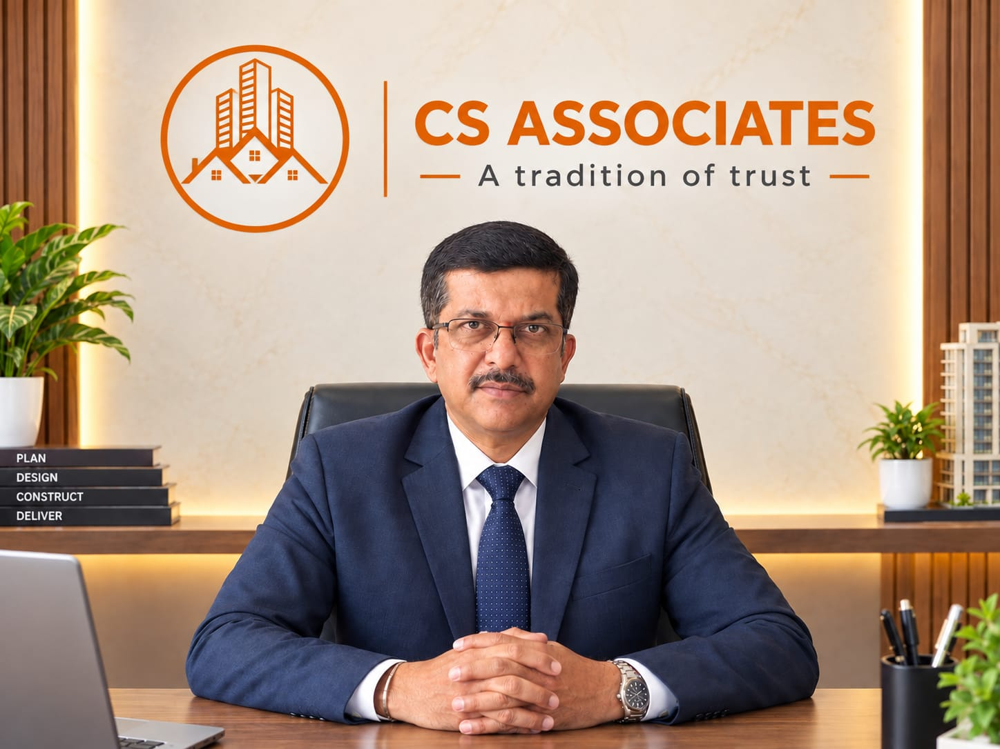
Mr. Kiran Dikshit L
Founder & Proprietor of CS Associates
Mr. Kiran Dikshit L is the driving force behind CS Associates with over 25+ years of hands-on experience in Project Management, Construction, and Infrastructure development.
Having managed residential villas, luxury homes, commercial buildings, and healthcare projects, he is known for his strict quality control, transparent working style, and commitment to on-time delivery.
His philosophy is simple - "A Tradition of Trust, Built with Quality. "He believes a project manager's job is not just to build, but to protect the client's money, time, and dream.
Under his leadership, CS Associates has become a trusted name for clients who want peace of mind and single-point ownership from planning to handover.
- Brand Colors (Optional): Specific color preferences or existing corporate color codes.

2. ABOUT US & TEAM DETAILS
Founder Bio: Brief summary (3-5 lines) covering 25+ years of PMC industry experience.
From Foundations to Finish Lines — Meet the Man Who Builds Dreams .
L. Kiran Dikshit isn’t just building structures — he’s constructing legacies, and setting milestones taller than Mount Everest (which, by the way, he dreams of reaching one day… after finishing site inspections).
With 25+ years in Project Management for Civil and Architectural ventures, Kiran has
worked with Fuego Furniture, Andagere Architects, and Synthesis
Architects, making him the go-to man when you want your project done on time, within
budget, and with a touch of brilliance.
Profession: Project Management (Civil & Architectural Projects)
Experience: 25+ years of planning, leading, executing, and turning blueprints into reality
OUR SERVICES
Turnkey project Manegment
Project Manegment Consultants
Architecture & interior Design Consultants
Vaastu Consultants
Electrical Consultants
Facade & Fenestration
Joint development

ABOUT CS ASSOCIATES
25+ years Project Manegment for civil
300k+ sqft Constructed
150+ Projects Delivered
120+ Happy Customer
200+ Amenities Created
WHY CS ASSOCIATES
Complete project Management
Quality Assurance
Cost effective Solutions
Customizable Services
Efficient Timelines
Personalized Attention
Post completion Support

- SERVICES PROVIDED (SCOPE & DESCRIPTIONS)
Project Management Consultancy (PMC): Short overview of end-to-end management from planning to handover.
END-TO-END PROJECT MANAGEMENT CONSULTANCY
From Planning to Handover - We Manage Everything.
At CS ASSOCIATES, we are your single-point partner who takes complete ownership of your project. You share your vision; we deliver the building - On Time, Within Budget, With Assured Quality.
OUR 7-STAGE PROCESS:
STAGE 1: PROJECT PLANNING & PRE-CONSTRUCTION
Feasibility study, budget estimation, drawing review, and detailed project schedule. We identify risks before they become costs.
STAGE 2: DESIGN & VENDOR FINALIZATION
Coordinating Architect, Structural, and MEP consultants. Assisting you in finalizing the right contractors and vendors through technical comparison - not just lowest price.
STAGE 3: SITE EXECUTION & SUPERVISION
Daily site supervision by our engineers. We control quality, workmanship, and safety. Daily Work Progress Report (DPR) with photos directly on your WhatsApp.
STAGE 4: QUALITY CONTROL & QUALITY ASSURANCE
Multi-level quality checks for civil, waterproofing, electrical, plumbing, and finishing works. No compromise, no hidden works.
STAGE 5: MATERIAL & BILLING MANAGEMENT
We verify all materials at site, control wastage, and check contractor bills with measurements. Our clients save 8-15% on total project cost.
STAGE 6: MEP & FINISHING COORDINATION
Seamless coordination of all services - Electrical, Plumbing, HVAC, Fire, Automation, Interiors - to ensure perfect finishing and zero rework.
STAGE 7: SNAG LIST & HANDOVER
Final finishing inspection, snag list closure, as-built drawings, warranty documents, and a peaceful, snag-free handover of your keys.
WHAT YOU GET:
✓ One Single Point of Contact
✓ Daily Transparency
✓ Cost Saving & No Extra Billing
✓ On-Time Delivery Guaranteed
✓ Peace of Mind

- Residential Projects & Luxury Villas: Brief notes on services provided for individual and luxury homes.
INDIVIDUAL HOMES & LUXURY VILLAS*
Crafting Bespoke Homes for Discerning Families_

At *CS ASSOCIATES*, we understand a luxury villa is not just construction - it's your family's legacy. We provide dedicated Project Management for individual homes where every detail matters.

*SERVICES FOR INDIVIDUAL & LUXURY HOMES:*

*1. Personalized Project Planning*
We start with your lifestyle. Detailed planning of space, Vastu, natural light, ventilation, and future needs. Complete budget breakdown and timeline before first brick.

*2. Design Realization*
We work with your Architect to ensure what is drawn is exactly executed on site. No deviation in dimensions, heights, or finishes.

*3. Premium Material Assistance*
Expert guidance in selecting Marble, Granite, Wood Veneer, Designer Tiles, Sanitary Fittings, Lights & Switches. We ensure you get genuine branded materials at best price.

*4. Dedicated Site Supervision*
Your home gets a dedicated engineer. Daily supervision of all works - Structure, Block work, Plastering, Waterproofing, Flooring, Painting, Fabrication & Woodwork.

*5. Luxury Finishing Management*
This is where we specialize. Groove detailing, mitre joints, shadow gaps, profile lighting, seamless flooring, zero-crack finish - We achieve designer-level finishing.

*6. Smart Home & MEP Integration*
Perfect coordination of Home Automation, Security, CCTV, Air Conditioning, Solar, Electrical & Plumbing for a modern, hassle-free luxury life.

*7. Transparent Billing & Cost Saving*
Every bag of cement, every tile, every payment is recorded. We cross-check contractor bills with actual site measurement. Clients save 10-15% overall.

*8. Final Styling & Handover*
Complete snag list checking, deep cleaning, final touch-ups, and peaceful handover with all warranties and drawings.

*PROMISE TO INDIVIDUAL HOME OWNERS:*
- You will have only ONE person to talk to - Us.
- You will get Daily Photos & Updates on WhatsApp.
- No headache of handling 15 different contractors.
- No compromise on quality. Ever.
- Commercial & Healthcare / Hospital Projects: Brief overview of commercial and hospital infrastructure work.

*COMMERCIAL & HEALTHCARE INFRASTRUCTURE*
_Building Business-Ready & Life-Saving Facilities_
At *CS ASSOCIATES*, we manage commercial and healthcare projects where *function, compliance, and deadline are non-negotiable.* We build facilities that perform 24/7 and deliver ROI from Day 1.
*A. COMMERCIAL PROJECTS*
_Offices | Retail | Showrooms | Business Complexes_
We understand time is money. Our focus is on fast-track, brand-perfect execution.
*What We Manage:*
1. *Space Optimization:* Maximum usable area with smart planning
2. *Brand & Aesthetics:* Finishing as per your brand identity
3. *MEP for Business:* High-load electrical, centralized AC, networking, fire & security
4. *Quick Handover:* Time-bound execution for early business start

*B. HEALTHCARE / HOSPITAL PROJECTS*
_Hospitals | Clinics | Diagnostic Centers | Labs_
We build hospitals that are safe for patients, efficient for doctors, and compliant for approvals.
*What We Manage:*
1. *Compliance Driven:* Execution as per NABH, Fire Safety, KSPCB & Health Dept norms
2. *Critical Areas:* OT, ICU, Emergency, Wards, Labs - with infection control & hygiene focus
3. *Medical Services Coordination:* MGPS (Medical Gas), HVAC, HT Electrical, Plumbing, Bio-medical waste routing, ELV
4. *Durable Finishing:* Anti-bacterial, chemical-resistant, high-traffic, low-maintenance materials

*OUR CORE STRENGTH IN THIS SECTOR:*

- *Statutory Approval Support* - We know what inspectors look for
- *Zero Rework MEP Coordination* - No clashes between services
- *Quality + Safety Audits* - Daily checks, no compromise
- *Billing & Budget Control* - Transparent billing, no extra claims

4. PROJECT PHOTOS (PAST & ONGOING WORK)
Finished Sites: 3-5 high-quality photos each of completed residential, commercial, or villa projects.
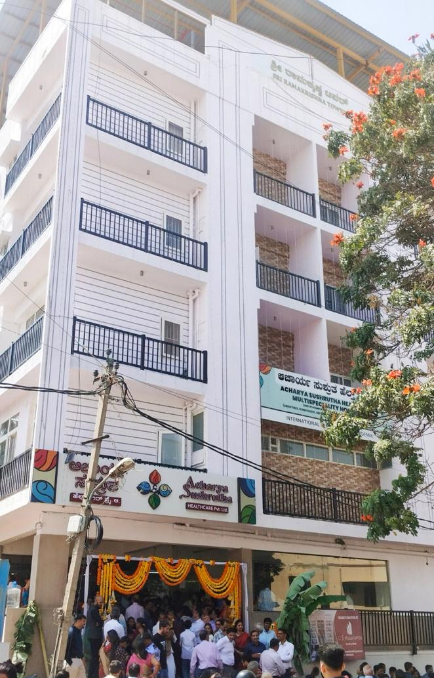
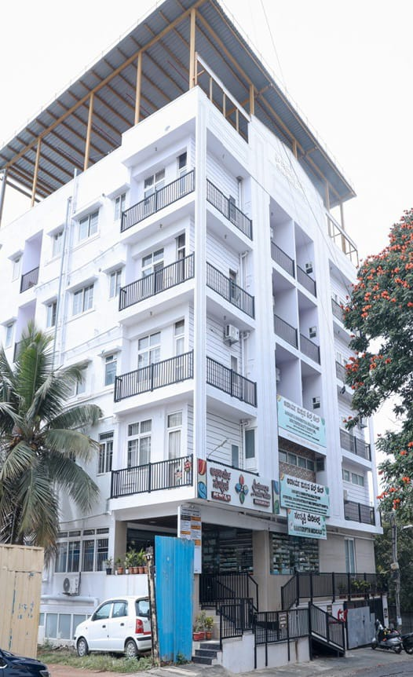

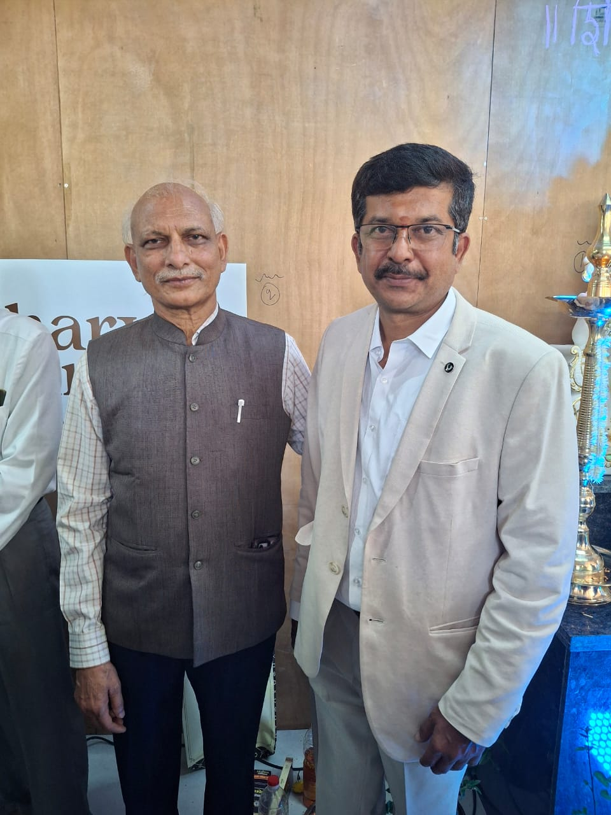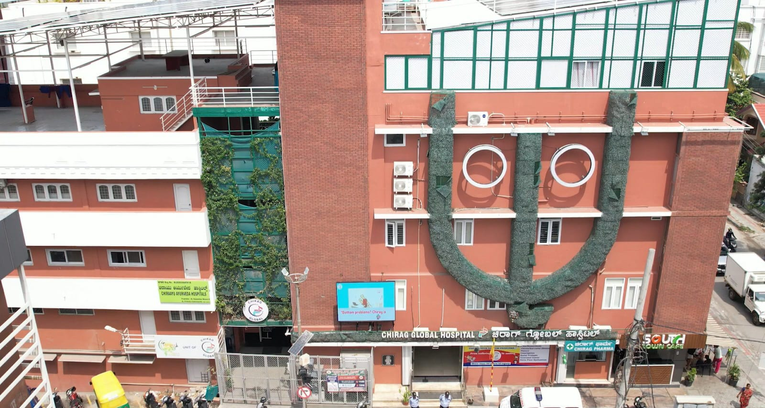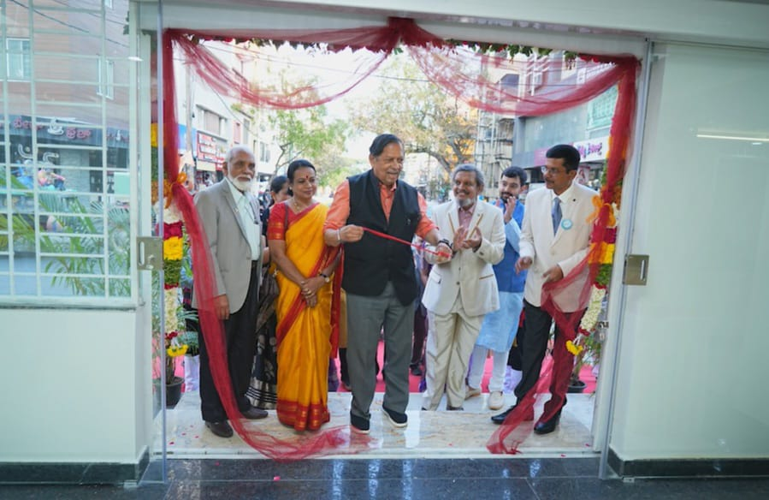

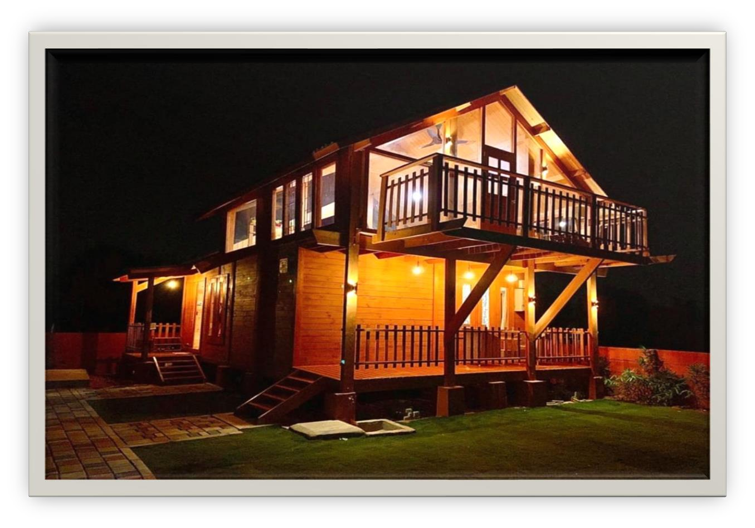

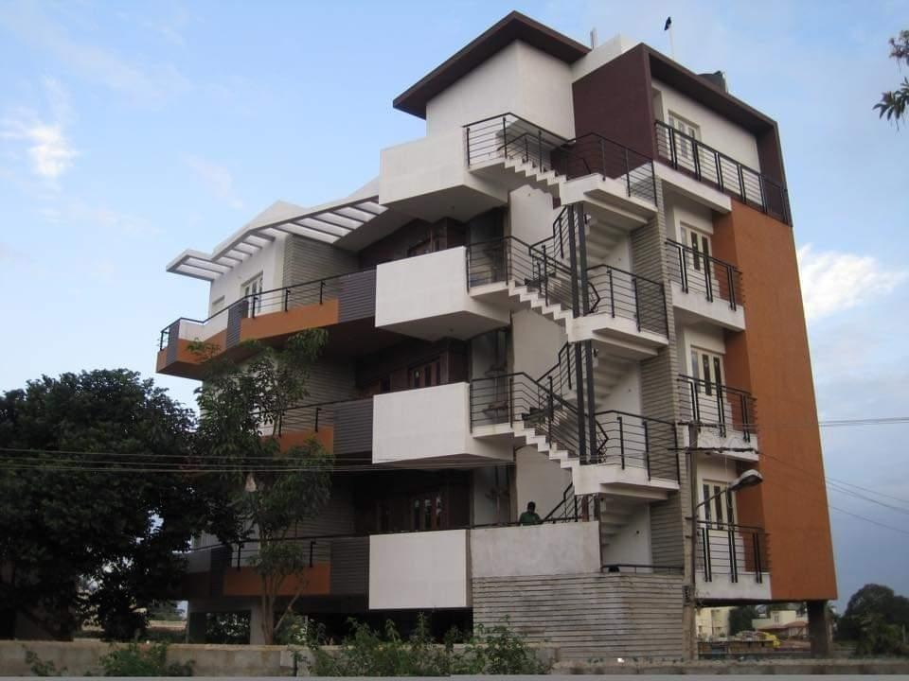

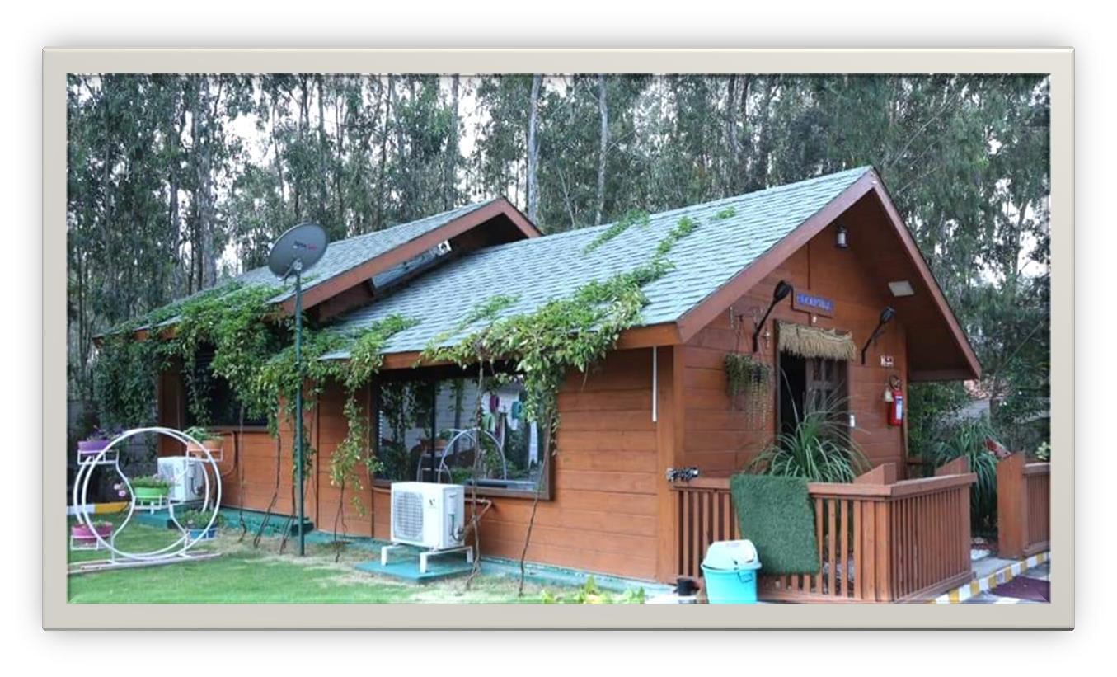
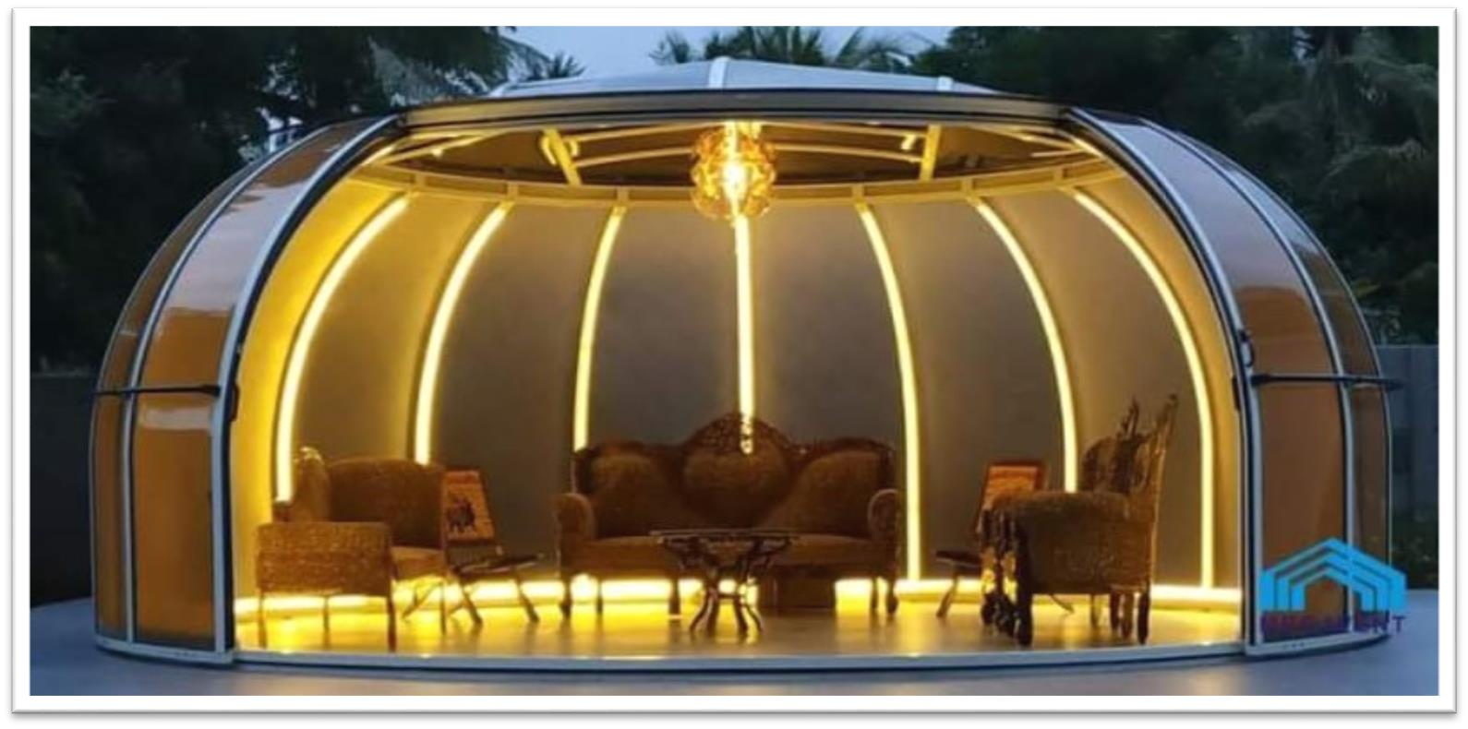

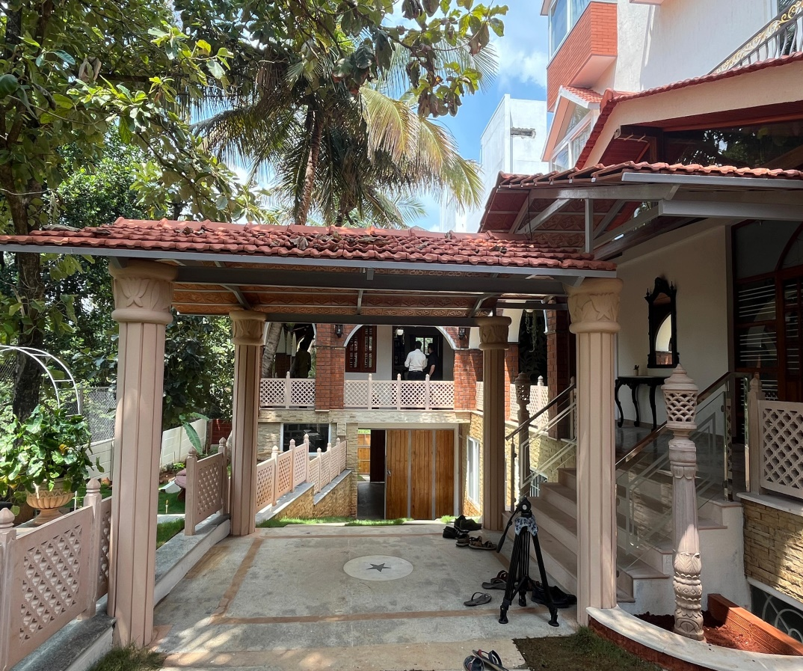

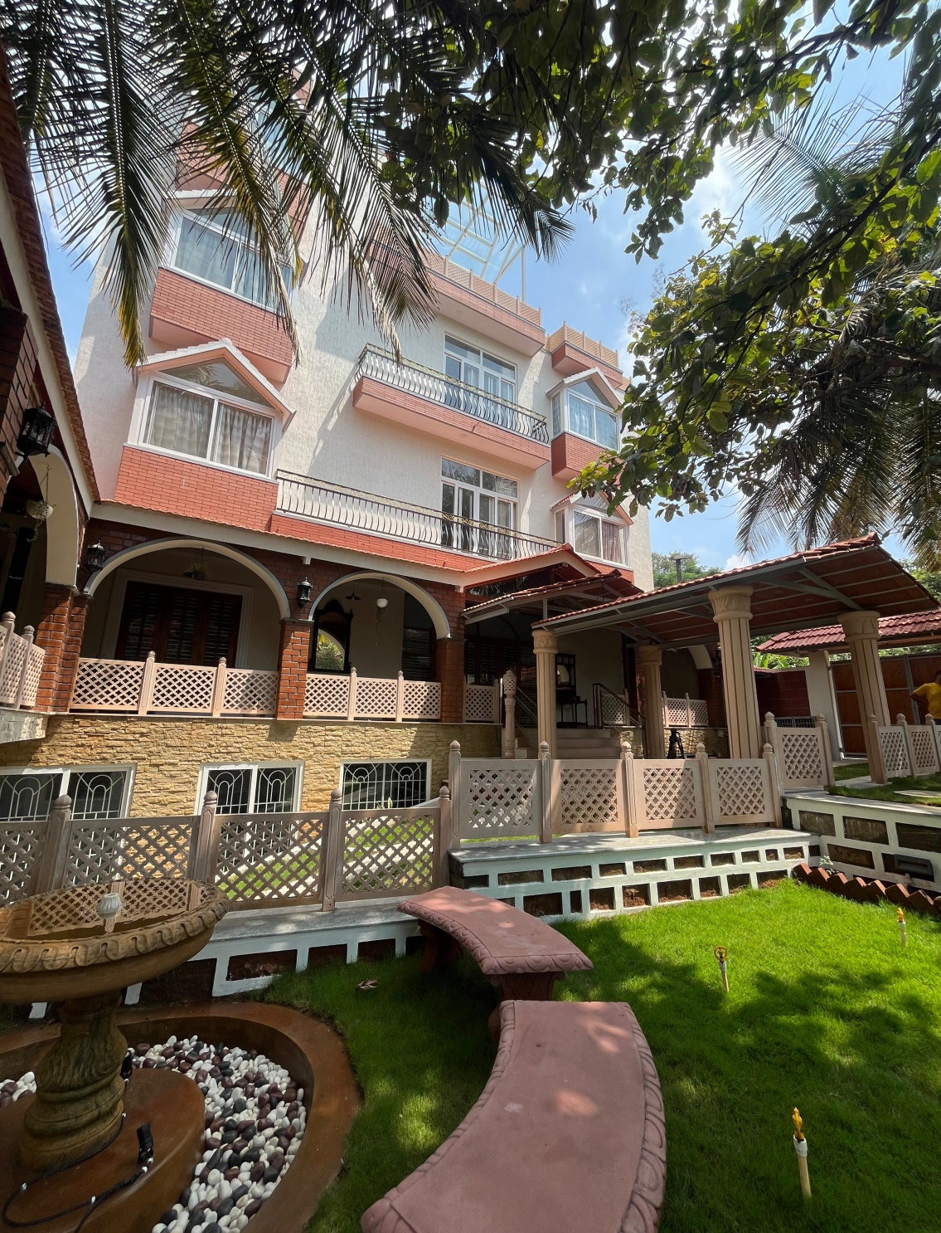

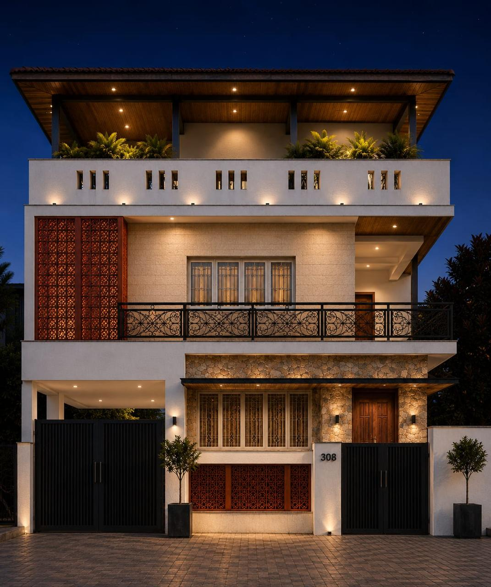
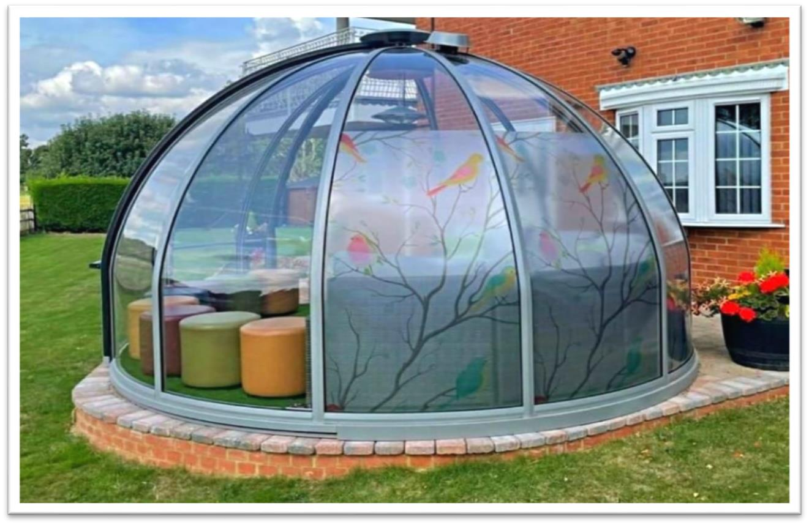 On-Site Photos: A few p hotos of active site work, blueprints, or site inspections.Project Names & Locations: 3 to 5 notable project names and their locations to showcase as examples

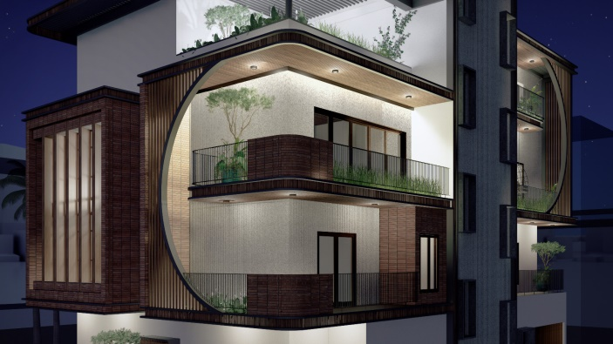

Dr Lakshmi Residence Project Abbigere

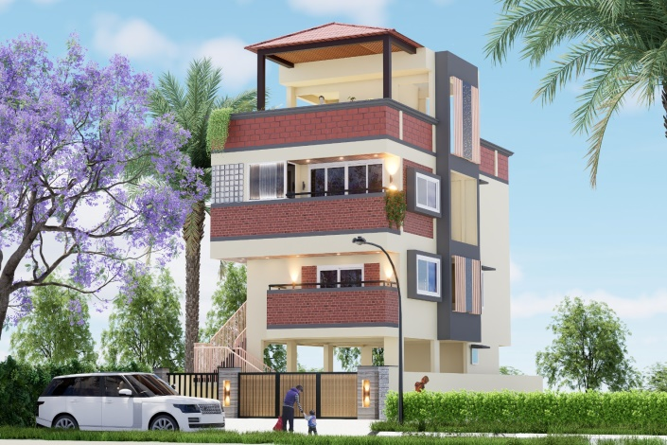

Site No 12 opulence Kanakapura Road Tataguni

5. OFFICIAL CONTACT & SOCIAL LINKS
- Phone Numbers: 8095823483, 8296266389.
- WhatsApp Number: 8296266389.
- Email Addresses: csassociates321@gmail.com).
- Social Media Links: https://www.instagram.com/csassociates_blr/
https://www.facebook.com/

- Office Address: 1678, NISARGA 4th cross 5th stage First phase, BEML layout, Rajarajeshwarinagar, Bangalore 560098
6. EXISTING MATERIALS (IF AVAILABLE)
- Company Profile / Brochure: Existing PDF brochure or presentation deck to take text directly from.
- Client Testimonials: 2-3 brief client quotes or feedback to build credibility. 